Notebook Prompts 3

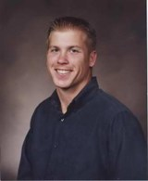
Above is a picture of the late Air Force Staff Sergeant Dean Witt. He didn’t die in a explosion in Afghanistan. He didn’t die in a terrorist attack. He died from a negligent nurse putting a breathing tube down the wrong side of his throat and suffocated his brain and turned him into a vegetable.


This is a picture of Dean Patrick with his wife before he was taken off of life support. Due to the Feres Doctrine his wife was unable to sue the negligent medical personnel for malpractice.


These are the Supreme Court justices that continue to uphold the Feres Doctrine, which neglects, abuses and kills our brave service men. The Ferese Doctrine has created a military medical field that has no accountability for malpractice.


Why would our judges uphold such a blatantly unfair and flawed law? Because it would cost the government too much money in malpractice and wrongful death lawsuits to justify repealing it. Obviously it is more important to protect the government’s bottom line than to protect military citizen’s rights and health.

